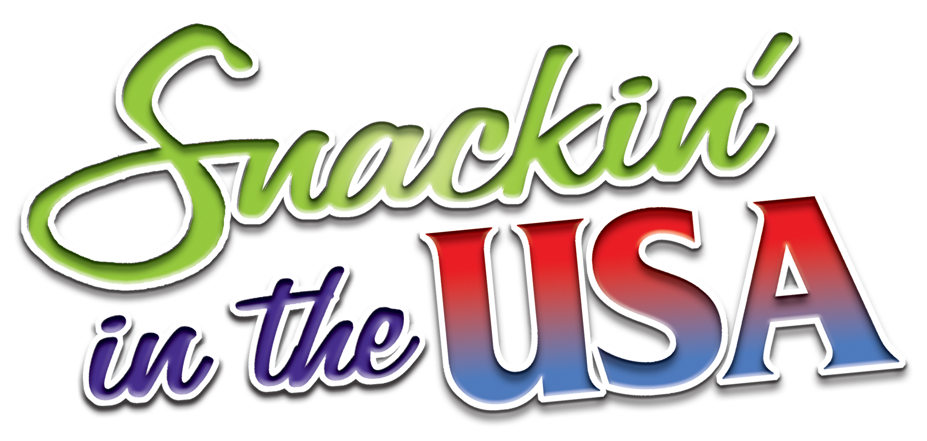

<Organization> is happy to be offering
this wonderfully delicious
and fun snack brochure for our upcoming fundraiser –
they are all so amazing!

This program is perfect for our group - and we’ll sell a lot -
the retail is only $10.00 per item… tasty and affordable.
Try some of our chocolate covered pretzels, cashews
or sour Gummi worms.

The profits from this fundraiser
will go towards <Parent Letter Selling Copy>

The official start date is <Kick Off Date> an
the official completion date is <End Date>.
Please keep all order forms in the collection
envelope provided and make sure your name is on it.
We will be accepting cash and…
Make checks payable to: <Organization>.

Never allow underage children to solicit orders alone.
They should always be in the company
of a responsible adult.

THANK YOU FOR
YOUR SUPPORT!

